For #1-3, determine whether the function is continuous and/or differentiable at the given point.
1) $f(x)=\begin{aligned}\left\{−3x^{2}+x,x≤−2 | \right.\end{aligned}$ 2) $g(x)=\begin{aligned}\left\{\sqrt{x−2},x<3 | \right.\end{aligned}$ 3) $h(x)=\begin{aligned}\left\{\frac{x−1}{x+4},x≥1 | \right.\end{aligned}$
$x=−2$ $x=3$ $x=1$
Analyze the graph to answer questions #4-6.
- At what values of x does the graph appear to be
both continuous and not differentiable.
- At what values of x does the graph appear to be
both discontinuous and not differentiable.
- At what values of x does the graph appear to be
both discontinuous and differentiable:
For #7-9, match the graph of the function with the graph of its derivative.
- 8) 9)

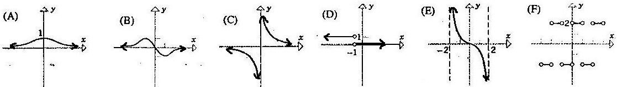
For #10-12, determine which graph represents the function and which graph represents the derivative. Circle BOTH if either graph could represent the function or the derivative.
10) Graph A Graph B 11) Graph A Graph B 12) Graph A Graph B
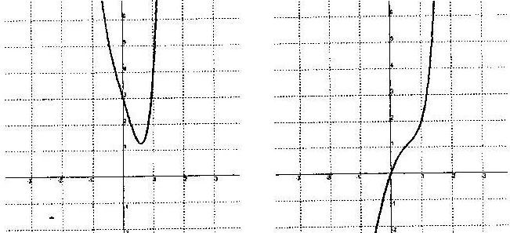
For #13-16 calculate the indicated derivative. Simplify your solutions but do not perform any FOIL.

- $f(x)=\frac{5}{2}x^{3}+\sqrt{x^{3}}−4x^{−5}+\frac{1}{3x}+\sqrt[3]{x^{4}}$ $f'(x)=$_____________________________

- $f(x)=\frac{4x^{2}−3x}{2−x}$ $f'(x)=$_____________________________

- $f(x)=(\text{10}x^{2}+7x+4)^{4}$ $f'(x)=$_____________________________

- $f(x)=\frac{5x^{3}+\text{12}x^{2}−8x+1}{3x^{2}}$ $f\text{'''}(x)=$____________________________
- Calculate the slope of the tangent to $f(x)=\sqrt{x^{2}+3x}$ at the point (1, 2).
- Find the x-values on the graph of $f(x)=\frac{1}{3}x^{3}−\text{10}x+4$ where the slope of the tangent is 15.
- Write the equation of the tangent line to the graph of $f(x)=3x^{2}+4x−2$ at (–2, 2).
- Find all x-values of $f(x)=\frac{1}{2}x^{4}+\frac{4}{3}x^{3}−3x^{2}$ at which there is a horizontal tangent line.

- Cont. Yes No
Diff. Yes No

- Cont. Yes No
Diff. Yes No

- Cont. Yes No
Diff. Yes No

- $x=$_________

- $x=$_________

- $h(x)=\begin{aligned}\left\{\frac{x−1}{x+4},x≥1 | \right.\end{aligned}$_________

- ____________

- ____________

- ____________

- A: $f(x)$ $f'(x)$
B: $f(x)$ $f'(x)$
BOTH
- A: $f(x)$ $f'(x)$
B: $f(x)$ $f'(x)$
BOTH
- A: $f(x)$ $f'(x)$
B: $f(x)$ $f'(x)$
BOTH

- ____________

- ____________

- ____________

- ____________

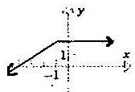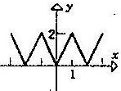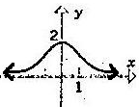

This Pretest is to be completed as preparation for the Unit Test and will be graded as a section of this test.
Collaboration with classmates is permitted, but copying work is considered cheating and will result in a zero.
The use of class notes is not permitted to complete this assignment.
